**Name**: Basket Cell (BC) (Buhl et al., 1996) – Hippocampal CA3 Interneuron

**Biological Data**

**Passive properties**: Vrest = -64.2 ± 7.2mV Tau = 9.8 ± 4.5 ms Rin = 31.3 ± 10.9 MΩ (Buhl et al., 1996)

________________________________________________________________________________________

**Passive properties of model OLM Interneuron:**

|  |
| --- |
| **1. V_rest = -61.1 mV**  **2. Calculation of time constant:**  Start inject: 300ms / -61.1mV Final Value: ~ -64.147mV Difference: -3.047 | 63.2% = -1.926 | -61.1 - 1.926 = - 63.026 Time at - 63.026: 113.7ms τ = 305.85-300  τ = 5.85 ms  **τ = .00585 s**  **3. Input Resistance**  ΔV/ΔI = ( -61.1 – (-64.147) )/( 0 – (-100) )  = 3.047mV / 100pA  **R_in = 30.47 MΩ** |

**Comparison of F-I curves (Actual: Green, Model: Black)**:

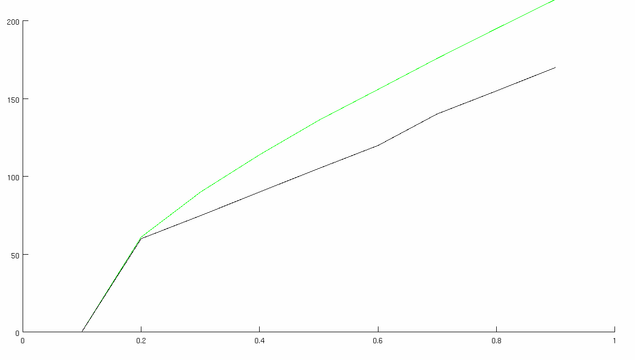

**Match with reported current injection responses (provide all):**

|  |  |  |
| --- | --- | --- |
| **400** |  |  |
| **pA** | **Real** | **Cell Model** |

**Table 2-1. GATING PARAMETERS OF ION CHANNELS**

|  |  |  |  |  |  |
| --- | --- | --- | --- | --- | --- |
| **Current Type** | **Gating Variable** | **α** | **β** | $$x_{∞}$$ | **τx (ms)** |
| *INa* | *p=3* | $$\frac{-0.4(V+30)}{exp[-(V+30)/10]-1 }$$ | $$\frac{0.5(V+30)}{exp[(V+30)/10]-1 }$$ | $$\frac{1}{\exp\left[(-V-38.43)/7.2\right]+1}$$ | $$\frac{0.6156}{α+β}$$ |
| *q=1* | $$\frac{-0.03(V+40)}{exp[-(V+40)/1.5]-1 }$$ | $$\frac{0.01(V+35)}{exp[(V+35)/1.5]-1 }$$ | $$\frac{1}{\exp\left[(V+50)/4\right]+1}$$ | $$\frac{0.6156}{α+β}$$ |
| *IKdr* | *p=1* | $$exp[-0.1247(V+15)]$$ | $$exp[-0.0125(V+15)]$$ | $$\frac{1}{\exp\left[(-15-V)/11\right]+1}$$ | $$\frac{8.33*β}{1+α}$$ |

**Table S2. Parameters of single cell models**

|  |  |  |
| --- | --- | --- |
|  | OLM interneuron | |
|  | soma | dendrites (1) |
| Cm (µF/cm2) | 1 | 1 |
| Ra (Ωcm) | 35.4 | 35.4 |
| Conductance (mho/cm2)  gNabar  gKdrbar  gLeak | 0.1  1.0359e-03  1.7e-4 | 0.1  0. 1.0359e-03  1.7e-4 |

**References**

Buhl EH, Szilagyi T, Halasy K, Somogyi P. 1996. Physiological properties of anatomically identified basket and bistratified cells in the CA1 area of the rat hippocampus in vitro. Hippocampus 6:294– 305.